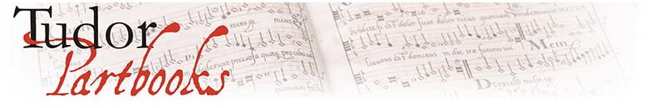
Registration Form

Workshop: Editing and Reconstructing the
Baldwin Partbooks (RECON II)
13-15 November 2015
Sidney Sussex College, Cambridge

Please return to katherine.butler@music.ox.ac.uk by 3 October

Name:

Institution:

Contact Address:

Email Address:

I will be attending:

☐ The whole event

OR the following sessions:
☐ Friday afternoon session
☐ Friday evening meal
☐ Saturday morning session
☐ Saturday lunch
☐ Saturday afternoon session
☐ Saturday evening meal
☐ Sunday morning session

I have the following dietary requirements:

I require the following special mobility, visual, or other arrangements:

I am / am not happy to be included in photos of the event for use on our website, social media and project newsletter (delete as applicable).
I do / do not require a certificate of attendance (delete as applicable).
☐ Please add me to the mailing list to be kept informed of future Tudor Partbooks events.

